**FT232/RD232**

**Driver Update Way After Device Identified Error**

**V1.0**

**STEP 1 : Identify IC Circumstances (Demo Under WIN7)**

A， Identify the ic type under WIN system

Insert your FT232/RD232 device dongle into PC USB port, and right click “Computer” 🡪 ”Properties” 🡪”Device Manager”

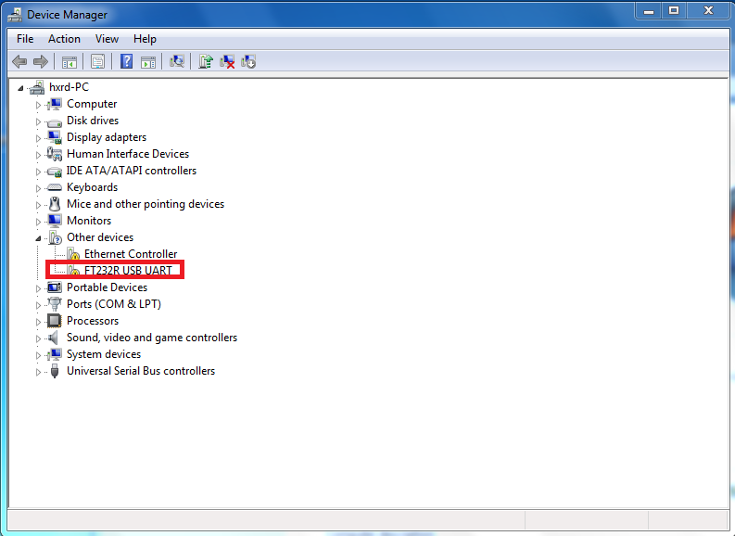

STEP 1 – A

Please goto STEP 1 – B, if thers is a [exclamatory mark](http://dict.cn/exclamatory%20mark) on FT232R USB UART.

B : Detect the IC type right away

Right click this device and enter “Proterties” 🡪 “Details” page 🡪 “Hardware ID”, as following : 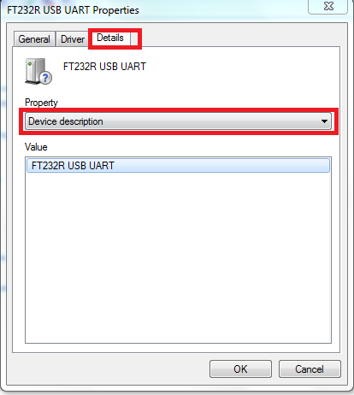

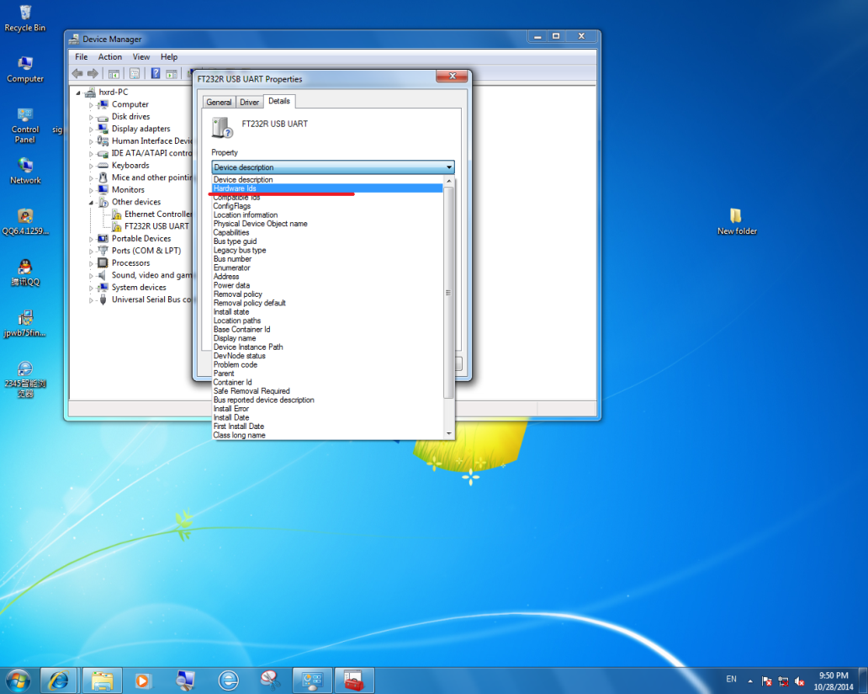

STEP1 - B

C，Find the Chip ID

If you find the PID with”0000”, Please goto STEP 4 directly.

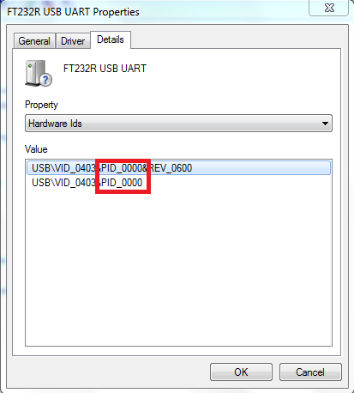

STEP 1 – C01

If you find the PID with “6001”, please goto STEP 2.

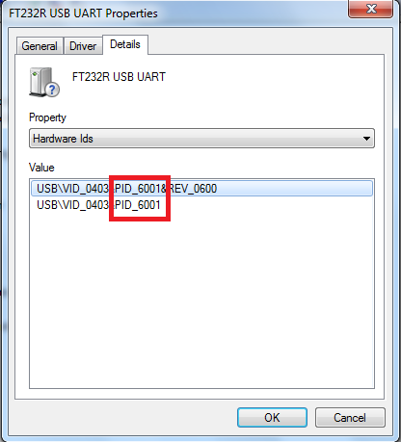

STEP 1 – C02

**STEP 2 : Install Driver 《CDM v2.12.00 WHQL Certified》**

A， Decompress the pakage : 《CDM v2.12.00 WHQL Certified》, and then goto the “Device Manager”, rightclick the device, and choose “Update Driver Software…”, Just as following :

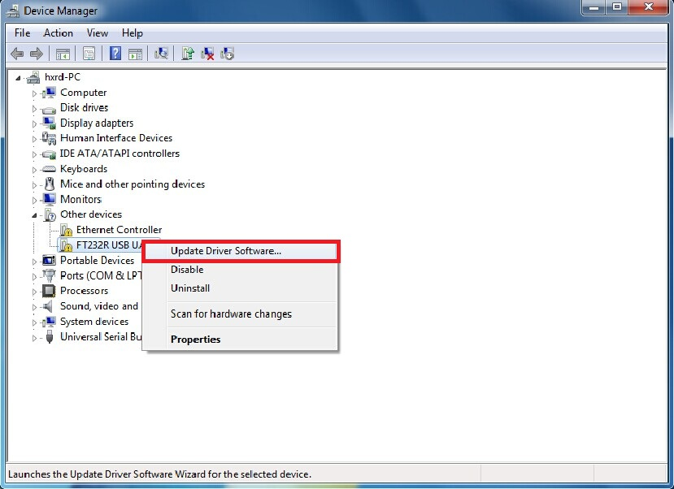

STEP 2 – A

B，Then choose ”Browse my computer for driver software”

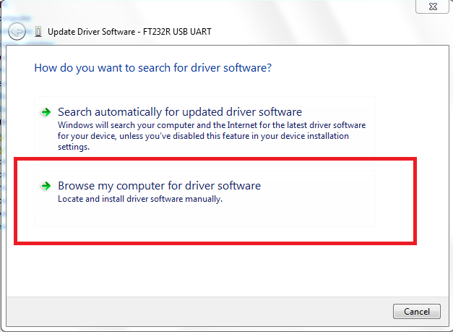

STEP 2 - B

C，Choose the driver in the dir which is decompressed right away.

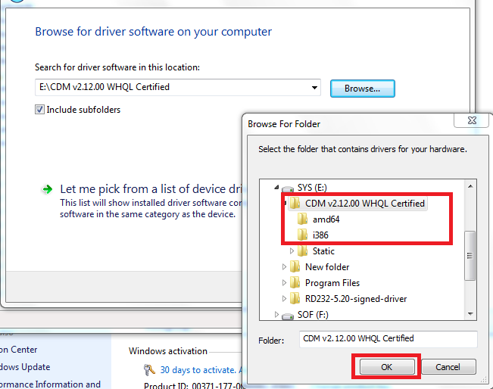

STEP 2 - C

D， Choose the “Next”, and the Driver will be installed correctly.

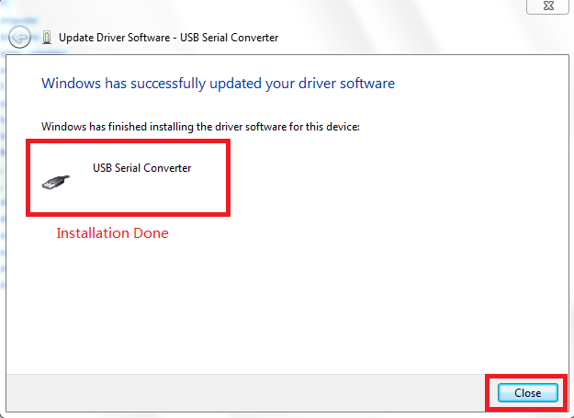

STEP 2 - D

E， Now, we have installed driver for USB Serial Converter, we still need to install the driver for USB serial Port. Please goto the “Device Manager” again.

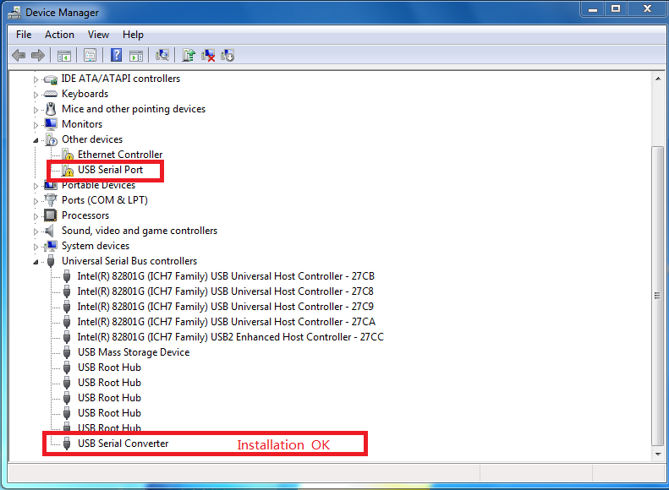

STEP 2 - E

F， As the same, please right click device “USB Serial Port”, choose “Update Driver Software…”.

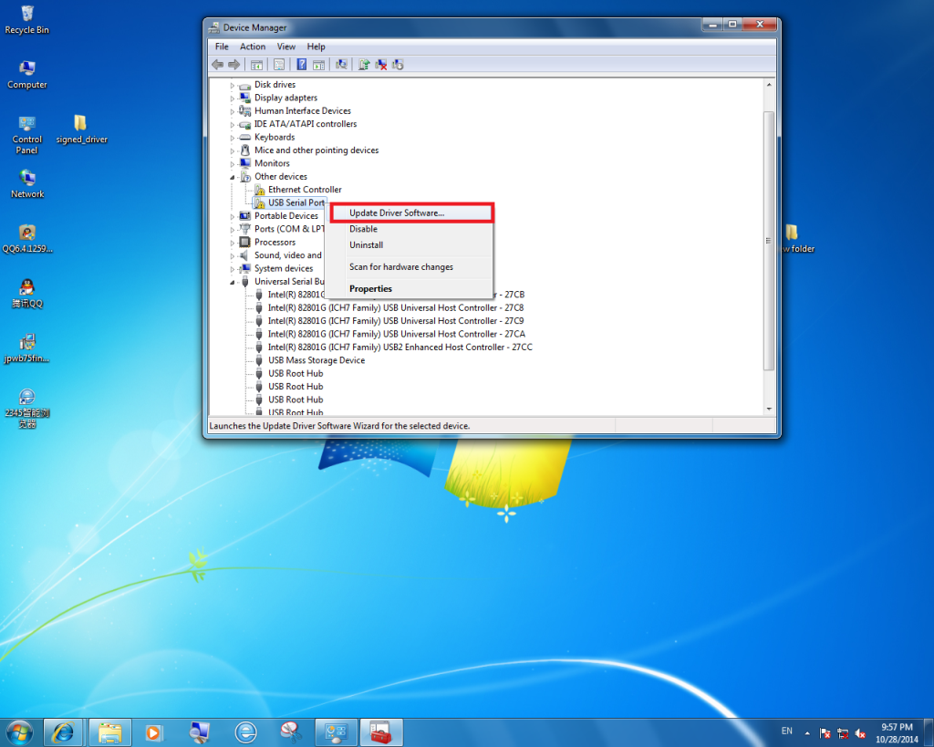

STEP 2 – F

G， Choose “Brower my computer for driver software”

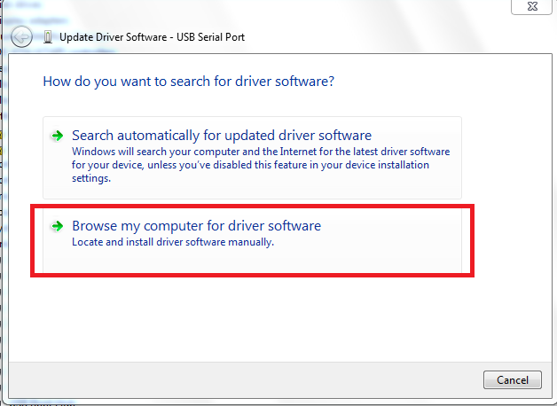

STEP 2 - G

H， Choose the dir which the driver decompressed



STEP 2 - H

I， Click “Next” and wait the driver installed ok

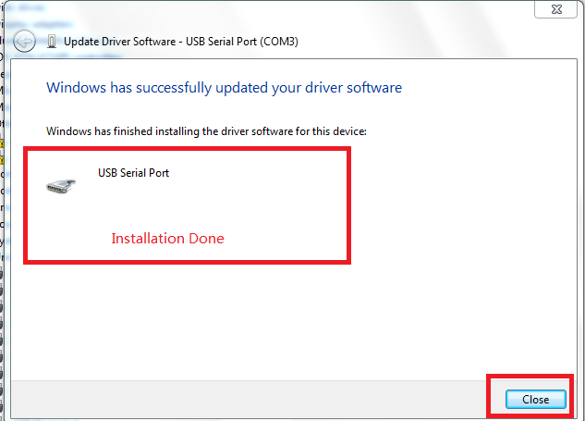

STEP 2 – I

J， The devices are all ok just as following.

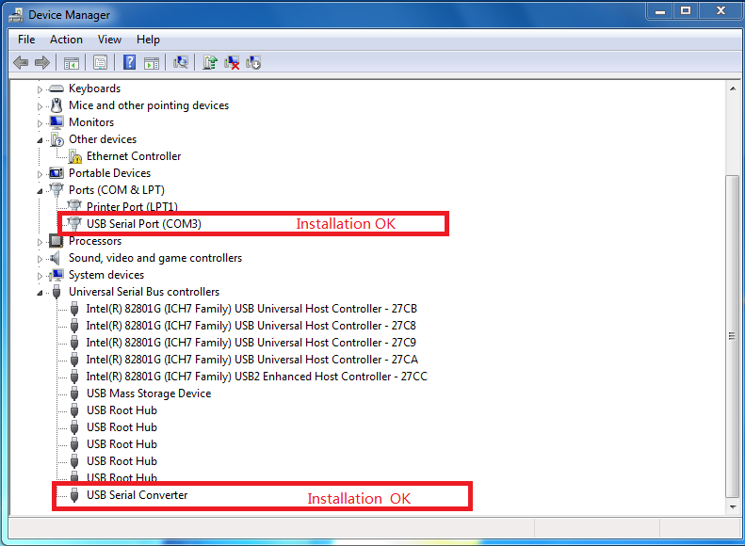

STEP 2 - J

**STEP 3 : Test the device**

A， Please unplug the FT232/RD232device from PC, and then re-insrt it into PC USB port, and re-goto “Device Magager”, now repeat STEP 1

If we find the “Hardware Ids” is changed to”0000” as following, please goto STEP 4.



STEP 3 - A

**STEP 4 ： Install driver**

**《RD232-5.20-WHQL-Certified-driver》**

A， Decompress the pakage : 《RD232-5.20-WHQL-Certified-driver》, and then goto the “Device Manager”, rightclick the device, and choose “Update Driver Software…”, Just as following :



STEP 4 – A

B，Then choose ”Browse my computer for driver software”



STEP 4 - B

C，Choose the driver in the dir which is decompressed right away.

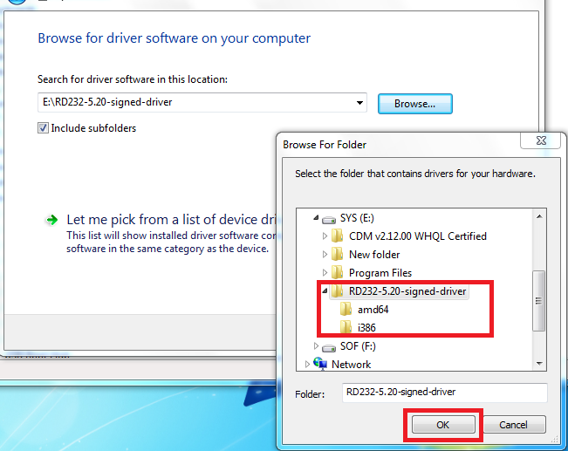

STEP 4 - C

D， Choose the “Next”, and the Driver will be installed correctly.



STEP 4 - D

E， Now, we have installed driver for USB Serial Converter, we still need to install the driver for USB serial Port. Please goto the “Device Manager” again.



STEP 4 - E

F， As the same, please right click device “USB Serial Port”, choose “Update Driver Software…”.

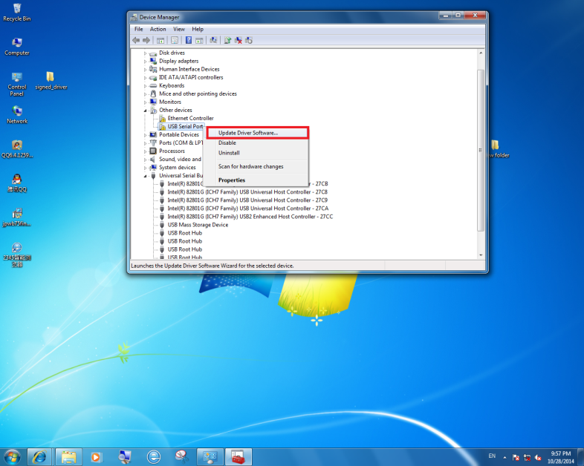

STEP 4 – F

G， Choose “Brower my computer for driver software”



STEP 4 - G

H， Choose the dir which the driver decompressed



STEP 4 - H

I， Click “Next” and wait the driver installed ok



STEP 2 – I

J， The devices are all ok just as following.



STEP 2 - J